# **1.0 Objectives**

In this lab you will learn how to create schematic diagrams in KiCad.

# 2.0 Parts List

| **Quantity** | **Item** | |
| --- | --- | --- |
| 1 | Computer with KiCad installed | |

**NOTE: The images and instructions for this lab are valid for KiCad version 8.08 on Windows 11. Icons and button locations may change if you use a different version of the software or OS. The keyboard shortcuts that are mentioned may differ as well.**

# 3.0 Background

## 3.1 What is KiCad?

KiCad is an open source software suite for Electronic Design Automation (EDA). It can handle Schematic Capture, which is the subject of this lab. It can also be used to design a Printed Circuit Board (PCB), which will be introduced in the next lab.

## 3.2 How to Install KiCad

If you are **NOT** using a lab computer, follow these steps to install KiCad on your machine:

1. Go to <https://www.kicad.org/download/> and click the icon for your Operating System. The possible options are shown in Figure 1.



Figure 1: KiCad is available for these operating systems.

1. Click on the Worldwide Github link in the displayed page and allow for the .exe to be installed (assuming you are running Windows). See Figure 2.

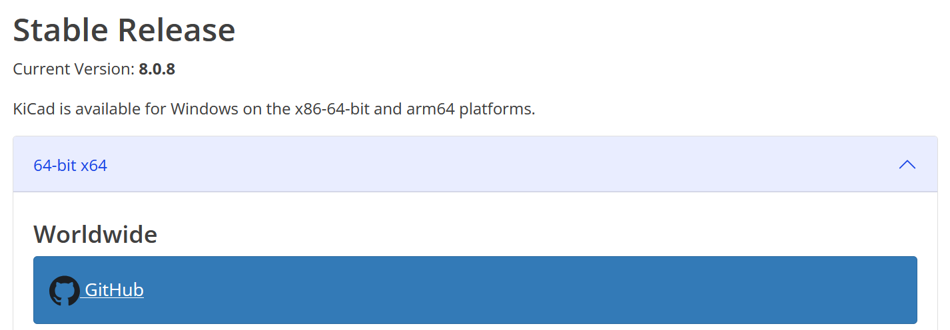

Figure 2: Use the GitHub link to download KiCad.

1. Run the .exe file and complete the setup by clicking “Next”. See Figure 3.

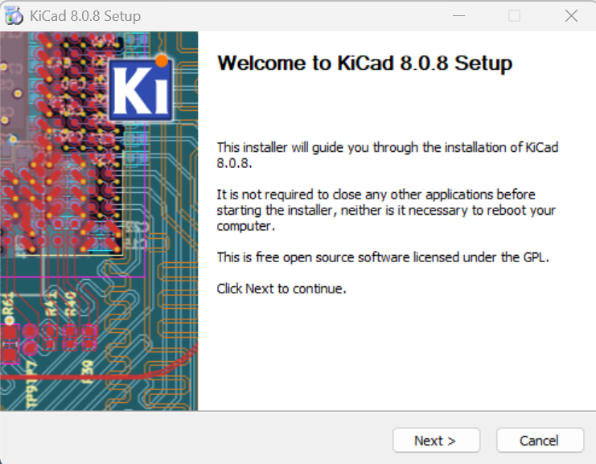

Figure 3: The main installation window.

1. When it asks you what libraries to install, keep them all checkmarked and click “Next”. See Figure 4.

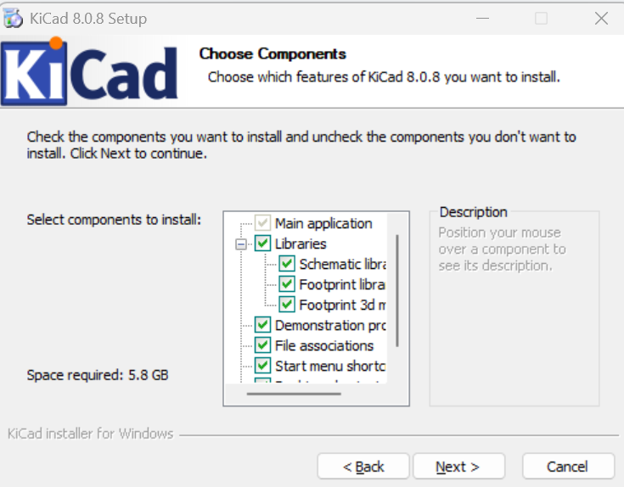

Figure 4: Install all libraries when given the choice.

1. Choose an appropriate destination folder and click “Install”. See Figure 5.



Figure 5: Select the destination folder.

1. Launch KiCad after the installation has finished. You are now ready to start the lab.

# 

# 4.0 Activity

Your task is to draw the schematic for the 8-bit 2-to-1 bus multiplexer from Lab 3 in KiCad. When finished, your diagram should look like the one shown in Figure 6. It is recommended that you watch the accompanying video before you proceed.

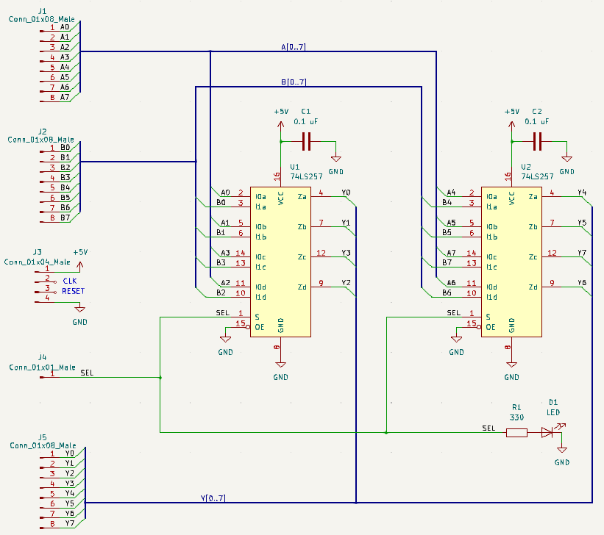

Figure 6: Finished schematic for the 2-to-1 bus multiplexer (8-bits wide).

## **4.1 Create a** New Project

* Create a project by selecting New → Project.
* Name the project and click Save.
* Create your schematic by clicking on the Schematic Editor (see Figure 7).



Figure 7: Schematic Editor.

* Choose the default settings when asked to *Configure the Global Symbol Library Table*.

## 4**.2** Add Components and Symbol Values

To add parts click on the Add Symbol button. Its icon is shown in Figure 8.



Figure 8: Add Symbol button.

Add two 74LS257 chips (see Figure 9). Each contains four 2-to-1 multiplexers. In Lab 3 we used 74HCT257N but the current version of KiCAD does not have that chip in its library. Nevertheless, you can use the alternative version for the schematic and replace it with the other chip once the PCB is ready. The two chips are pin-to-pin compatible and have the same physical dimensions. Show your progress on the schematic to the TA before you proceed.

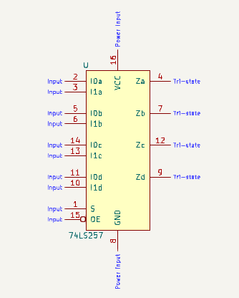

Figure 9: Schematic for the 74LS257 chip.

Add one LED, one resistor, and two capacitors. These components will be denoted with LED, R, and C, respectively (see Figure 10). You will be assigning the values for the resistors and capacitors later in the lab.

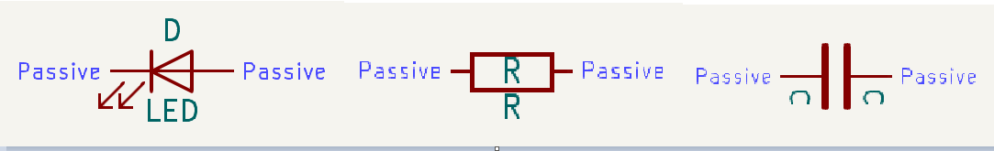

Figure 10: Basic components.

## 4**.3** Add Inputs and Outputs

Place three Conn_01x08_Pin components. These will act as the input buses (A and B) and the output bus (Y). Each of them has 8 pins as shown in Figure 11.

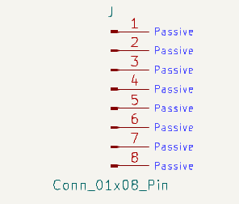

Figure 11: Connector component for input or output bus.

Place one Conn_01x01_Pin component (see Figure 12). This will act as the select line for the bus MUX.

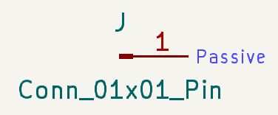

Figure 12: Connector component for the select line.

Place one Conn_01x04_Pin component (see Figure 13). This will act as the source of the power and ground lines as well as clock and reset.

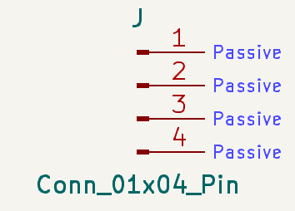

Figure 13: Connector component for the general control module.

## 4.4 Add Buses, Wires, and Connections

Place a bus by pressing B or clicking on the Add Bus button (see Figure 14). Press End to finish placing a bus segment. The bus should be placed near, but not connected to, a connector component. You need to add individual wires, one by one, to connect components to the bus.



Figure 14: Add Bus button.

Add wire entry and exit points to the bus by pressing Z or clicking on the Add Wire to Bus Entry button (its icon is shown in Figure 15).



Figure 15: Add Wire to Bus Entry button.

Connect the component to the bus entry using wires. Place wires by pressing W or clicking on the Add Wire button shown in Figure 16.



Figure 16: Add Wire button.

Repeat the steps above until every 8-bit connector is connected to its own bus.

Then, connect each bus to the chips. You will be using bus entries and wires to make these connections:

* + Bus A should connect to pins 2, 5, 11, and 14 on each chip.
  + Bus B should connect to pins 3, 6, 10, and 13 on each chip.
  + The output bus should connect to pins 4, 7, 9, and 12 on each chip.

Next, connect the select line to pin 1 of both chips. Connect this line to the resistor as well. Connect the LED to the other end of the resistor. The LED arrows should point away from the resistor, as shown in Figure 17. Show your progress on the schematic to the TA before you proceed.

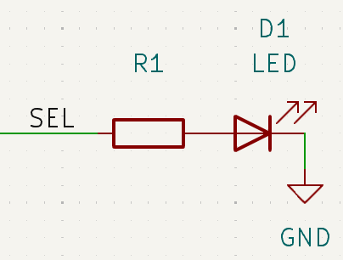

Figure 17: Connected resistor and LED.

## 4.5 Connect Power and Ground

Press P or click on the Add Power button (see Figure 18) to open the power symbol options.



Figure 18: Add Power button.

For power you want to use the +5V power supply. Add a power supply to the following:

* + Pin 16 of both chips.
  + Pin 1 of the general control module (see Figure 13).

For ground you want to use GND. Ground the following:

* + Pins 15 and 8 of each chip.
  + The side of the LED that's not connected to the resistor.
  + Pin 4 of the general control module.

For each chip, attach a decoupling capacitor (a.k.a bypass capacitor) to the connection between pin 16 and power. Ground the other end of the capacitor. See Figure 19 for reference.

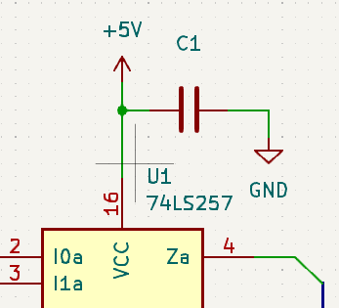

Figure 19: Connecting the capacitor to a chip.

## 

## 4.6 Label the Schematic

Adjust the capacitance value of each capacitor and the resistance value of the resistor. To do this, double click a component and set the value into the value field. Or press V while hovering over the component and type the value into the text field. After setting the value click OK to save and return to the schematic.

* + For the capacitors set the value to 0.1uF (which stands for 0.1 μF).
  + For the resistor set the value to 330 (which maps to 330 Ω).

Add Labels to the schematic by clicking the Add Label button (see Figure 20) or pressing the L key on the keyboard.



Figure 20: Add Label button.

The connectors should have corresponding J reference designations according to the following:

* Input connector A should be J1.
* Input connector B should be J2.
* The General Control Module should be J3.
* The select line should be J4.
* Output bus Y should be J5.

Add labels for all connectors. See Figure 6 on page 4 for an example. If needed, these can be changed by double clicking on the reference designation.

Now label all inputs and pins:

* Individual inputs A0 through A7, B0 through B7, and outputs Y0 through Y7.
* Label the buses with A[0..7], B[0..7], and Y[0..7].
* Label the bus connections to the pins of each chip. Label which input enters the pin or what output exits the pin.
* Label the select line SEL. Propagate that label to the chips and the resistor.
* Label the middle pins of J3 as CLK and RESET. These are not used by this circuit, but we need them for consistency with the other components of the CPU.

Show your progress on the schematic to the TA before you proceed.

## 

## 4**.**7Annotate The Schematic

Now that the schematic is complete, it is necessary to perform a few more steps to prepare it for Lab 5 where we will design a PCB from it. To begin, each component needs a unique reference designation. This was assigned in the last step. In order to avoid duplicate designations caused by human error, KiCad has a tool that adjusts designations so that they are all unique. As it has already been ensured that the designations are unique, this tool won’t have an effect in this case. Nevertheless, you should still run it:

* Navigate to the Tools dropdown and click Annotate Schematic. You will see a popup window similar to Figure 21.
* Without changing the defaults, click Annotate and wait for the tool to finish.
* Once you receive the message Annotation Complete, click Close.

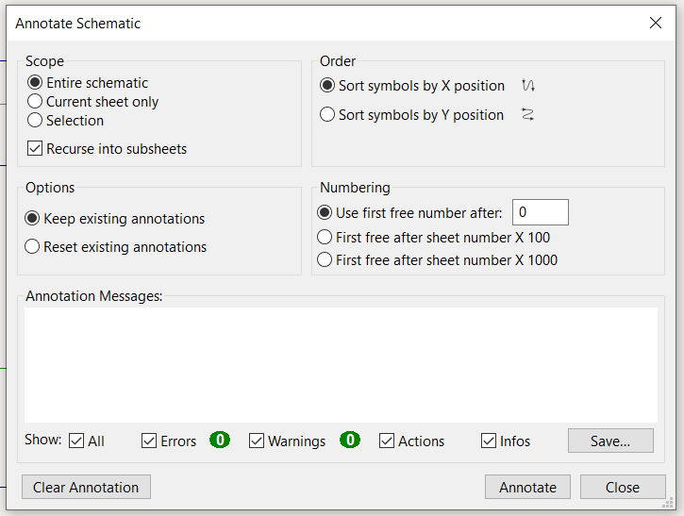

Figure 21: Annotate Schematic tool.

## 

## 4.8 Assign Footprints

To ensure that the schematic is ready for PCB routing, each component must be assigned to a comparable hardware component. In KiCad this is accomplished by assigning footprints.

* Navigate to the Tools dropdown and click Assign Footprints. Once the tool loads, you will see a popup window similar to Figure 22. However, the symbols won’t have assignments yet.

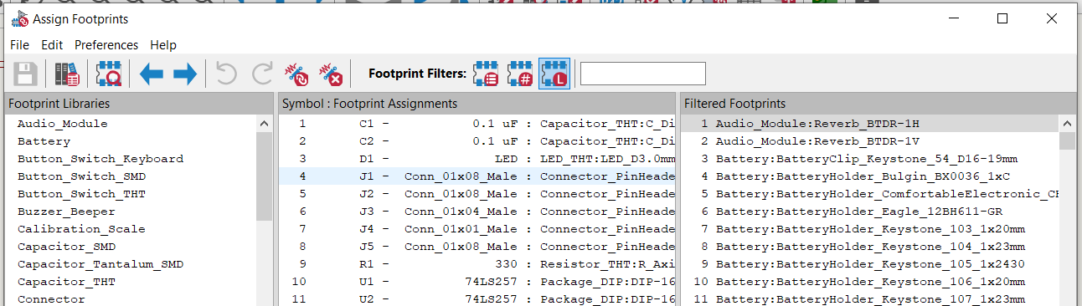

Figure 22: Assign Footprints tool.

To assign a footprint click on the component in the center column. Then, filter the footprint options by selecting the appropriate library for the component in the left column. Once the library is selected, search the right column for the specific part. After you find it, click on its name in the list to select it as the footprint for this component.

* For capacitors use the Capacitor_THT library and set the footprint to:
* Capacitor_THT:C_Disc_D5.0mm_W2.5mm_P5.00mm
* For the LED use the LED_THT library and set the footprint to: LED_THT:LED_D3.0mm
* For the connectors use the Connector_PinHeader_2.54mm library.

The 8-bit connectors/inputs/output need this footprint: Connector_PinHeader_2.54mm:PinHeader_1x08_P2.54mm_Vertical

The 4-bit connector/control module uses this footprint: Connector_PinHeader_2.54mm:PinHeader_1x04_P2.54mm_Vertical

The 1-bit connector/control module uses this footprint: Connector_PinHeader_2.54mm:PinHeader_1x01_P2.54mm_Vertical

* For the resistor use the Resistor_THT library and set the footprint to: Resistor_THT:R_Axial_DIN0207_L6.3mm_D2.5mm_P7.62mm_Horizontal
* The MUX components are in the Package_DIP library. Set their footprint to: Package_DIP:DIP-16_W7.62mm_Socket

Once you finish assigning the footprints, show your final schematic to the TA. Then, click on the “Apply, Save Schematic & Continue” button and click close. Finally, don’t forget to save your project.